

Students Name | SAP ID
Sahar Ayub | 70172989

CN Project

For
Software Engineering
Instructor | Sir. Habib ullah Shah
Semester | Fall 2025

Department of Software Engineering
The University of Lahore, Lahore, Pakistan

VIC MODERN HOTEL
(COMPUTER NETWORKS PROJECT DOCUMENTATION)
1. Introduction
This project presents the design and implementation of a structured computer network for Vic Modern Hotel, developed as part of the Computer Networks course. The goal of the project is to design a realistic, scalable, and secure enterprise network using Cisco Packet Tracer, implementing core networking concepts such as VLANs, subnetting, routing, DNS, DHCP (conceptually), and OSPF.
The hotel consists of three floors, each hosting multiple departments with specific networking needs. The designed network ensures full inter-department communication, logical separation of traffic, and efficient routing, while following real-world enterprise networking practices.
2. Organizational Requirements
Vic Modern Hotel has the following structure:
1st Floor
- Reception
- Store
- Logistics
2nd Floor
- Finance
- Human Resources (HR)
- Sales / Marketing
3rd Floor
- Information Technology (IT)
- Administration (Admin)
Each department requires:
- Dedicated network segmentation
- Wired and wireless connectivity
- A network printer
- Communication with all other departments
2.1 Screenshot (Flooring):
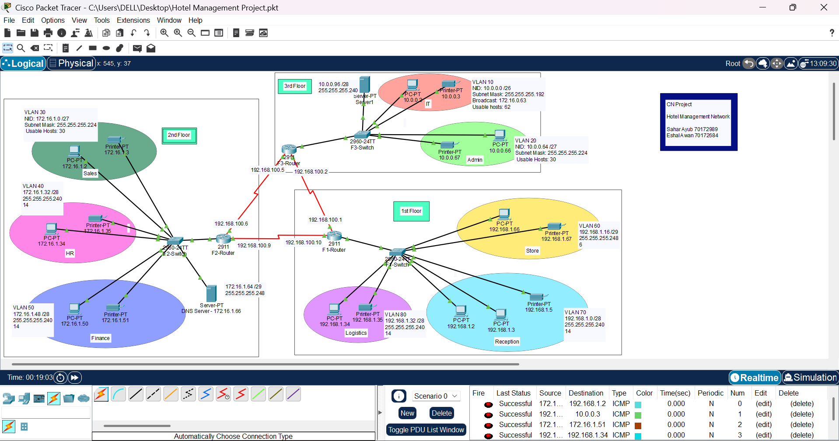
3. Network Design Overview
3.1 Physical Topology
- Three routers, one per floor, all placed in the IT Server Room
- Routers interconnected using serial DCE cables
- One switch per floor
- End devices include:
- PCs
- Printers
- Servers
- Wireless devices (laptops and phones via Wi-Fi)
3.2 Logical Topology
- Each department is placed in a separate VLAN
- Inter-VLAN routing is handled by routers
- OSPF (Open Shortest Path First) is used for dynamic routing
- All IP addresses are manually assigned

3.3 Screenshot (Topology):
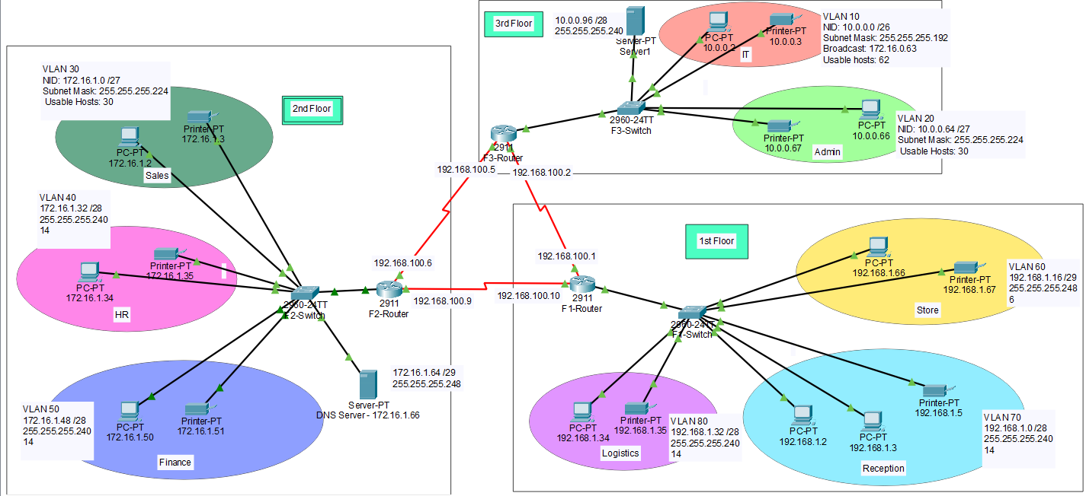

- VLAN and IP Addressing Scheme
  - Class-based IP Allocation
The Vic Modern Hotel network uses a hierarchical IP addressing scheme based on IP classes per floor, followed by VLSM (Variable Length Subnet Masking) to efficiently allocate addresses to individual departments. This design ensures scalability, efficient address utilization, and logical separation of traffic.
Floor | Departments | IP Class | Network Block
3rd Floor | IT, Admin, Servers | Class A | 10.0.0.0/16
2nd Floor | Sales, HR, Finance, Server | Class B | 172.16.1.0/16
1st Floor | Store, Reception, Logistics | Class C | 192.168.1.0/24

- Higher floors with critical systems are allocated larger address spaces
- Follows real enterprise hierarchical IP planning
- Simplifies future expansion and troubleshooting

4.2 VLAN Allocation
Floor | Department | VLAN ID | Network Address
1st | Reception | VLAN 70 | 192.168.1.0/28
1st | Store | VLAN 60 | 192.168.1.16/29
1st | Logistics | VLAN 80 | 192.168.1.32/28
2nd | Sales | VLAN 30 | 172.16.1.0/27
2nd | HR | VLAN 40 | 172.16.1.32/28
2nd | Finance | VLAN 50 | 172.16.1.48/28
3rd | IT | VLAN 10 | 10.0.0.0/26
3rd | Admin | VLAN 20 | 10.0.0.64/27
3rd | Core Servers | VLAN 99 | 10.0.0.96/28

4.3 Purpose for VLANs
- Improves security by isolating departments
- Reduces broadcast traffic
- Simplifies management
- Matches real-world enterprise hotel environments

4.4 Screenshot
VLAN (1st Floor)
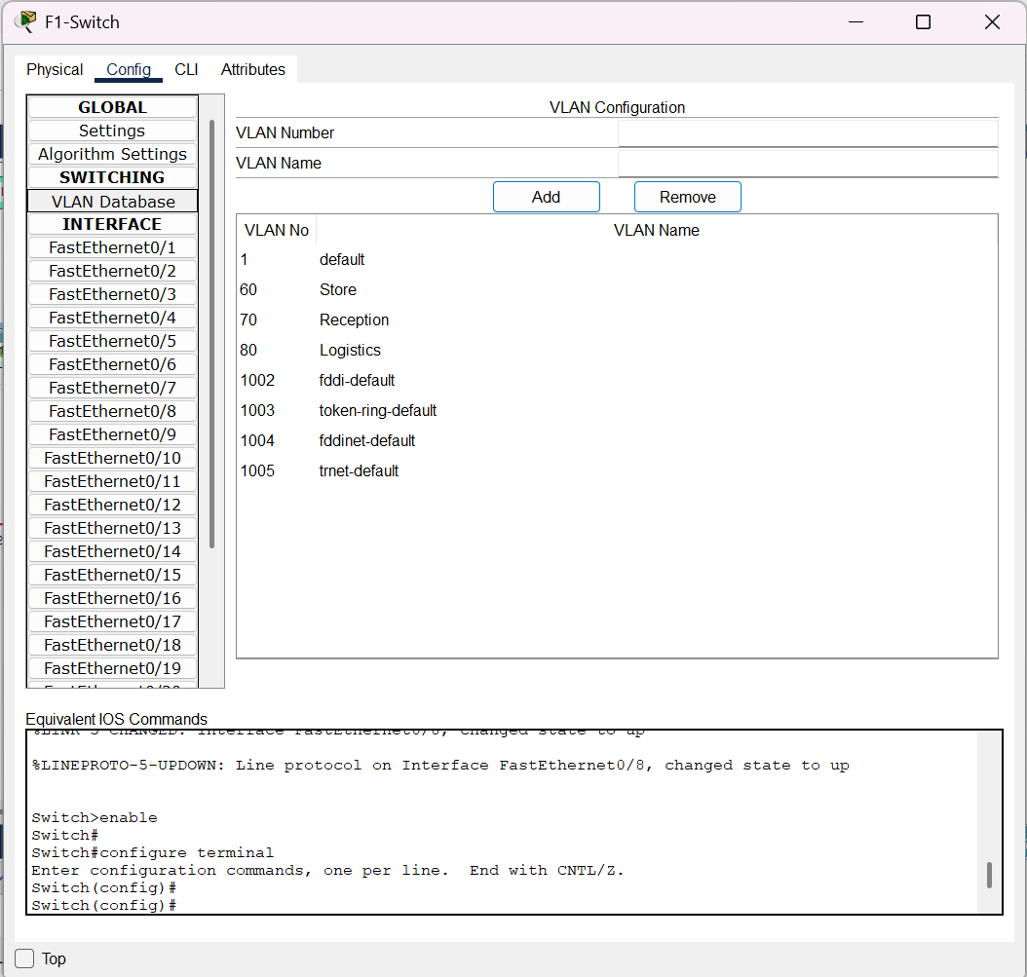

VLAN (2nd Floor)
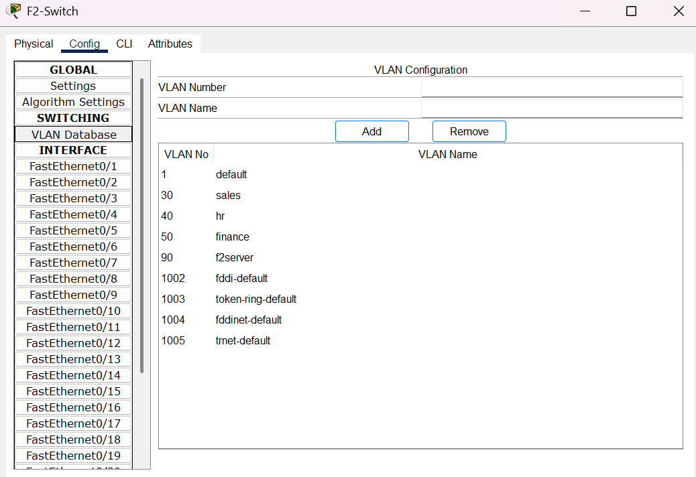

VLAN (3rd Floor)
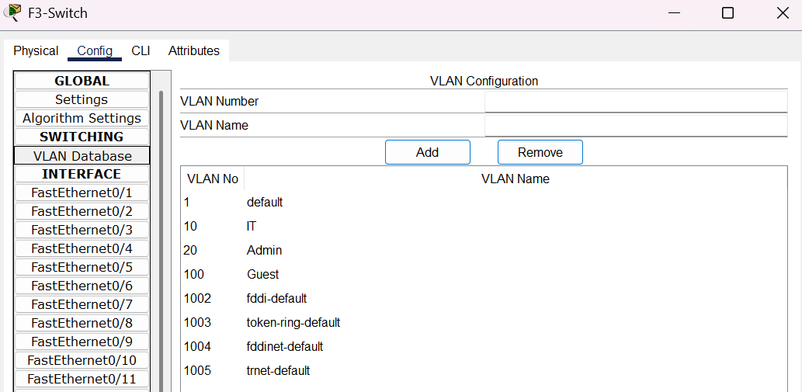

5. VLAN-Wise Subnetting Using VLSM
To avoid IP wastage and meet departmental size requirements, VLSM is implemented within each floor’s reserved network.
5.1 3rd Floor – IT, Admin, and Core Servers
(Hotel Backbone Floor)
Base Network: 10.0.0.0/16
Departmental Requirements
VLAN | Department | Purpose
10 | IT | Large staff, testing systems
20 | Admin | Management and control
99 | Core Servers | PMS, billing, database, CCTV

Subnet Size Decisions
Department | Required Hosts | Selected Prefix
IT | ~50+ | /26
Admin | ~20 | /27
Servers | ~10 | /28

3rd Floor VLSM Allocation
VLAN | Department | Network | Prefix | Usable IP Range | Broadcast
10 | IT | 10.0.0.0 | /26 | 10.0.0.1 – 10.0.0.62 | 10.0.0.63
20 | Admin | 10.0.0.64 | /27 | 10.0.0.65 – 10.0.0.94 | 10.0.0.95
99 | Servers | 10.0.0.96 | /28 | 10.0.0.97 – 10.0.0.110 | 10.0.0.111

5.2 2nd Floor – Sales, HR, Finance
(Hotel Operations Floor)
Base Network: 172.16.1.0/16
Departmental Requirements
VLAN | Department | Purpose
30 | Sales | Corporate bookings, events
40 | HR | Staff management
50 | Finance | Billing and payroll
98 | Dept Server | Local applications

Subnet Size Decisions
Department | Required Hosts | Prefix
Sales | ~25 | /27
HR | ~10 | /28
Finance | ~10 | /28
Server | ~6 | /29

2nd Floor VLSM Allocation
VLAN | Department | Network | Prefix | Usable IP Range | Broadcast
30 | Sales | 172.16.1.0 | /27 | 172.16.1.1 – 172.16.1.30 | 172.16.1.31
40 | HR | 172.16.1.32 | /28 | 172.16.1.33 – 172.16.1.46 | 172.16.1.47
50 | Finance | 172.16.1.48 | /28 | 172.16.1.49 – 172.16.1.62 | 172.16.1.63
98 | Server | 172.16.1.64 | /29 | 172.16.1.65 – 172.16.1.70 | 172.16.1.71

5.3 1st Floor – Reception, Store, Logistics
(Guest-Facing and Operational Floor)
Base Network: 192.168.1.0/24
Departmental Requirements
VLAN | Department | Purpose
70 | Reception | Front desk operations
60 | Store | Inventory management
80 | Logistics | Supplies and movement

Subnet Size Decisions
Department | Required Hosts | Prefix
Reception | ~12 | /28
Store | ~8 | /29
Logistics | ~15 | /28

1st Floor VLSM Allocation
VLAN | Department | Network | Prefix | Usable IP Range | Broadcast
70 | Reception | 192.168.1.0 | /28 | 192.168.1.1 – 192.168.1.14 | 192.168.1.15
60 | Store | 192.168.1.16 | /29 | 192.168.1.17 – 192.168.1.22 | 192.168.1.23
80 | Logistics | 192.168.1.32 | /28 | 192.168.1.33 – 192.168.1.46 | 192.168.1.47

5.4 Custom Subnet Mask for each VLAN
3rd Floor – IT, Admin & Core Servers
Base Network: 10.0.0.0/16 (Class A)
VLAN | Department | Prefix | Subnet Mask | Usable Hosts | Why This Mask
10 | IT | /26 | 255.255.255.192 | 62 | IT has most staff, systems, and future growth
20 | Admin | /27 | 255.255.255.224 | 30 | Moderate number of management devices
99 | Core Servers | /28 | 255.255.255.240 | 14 | Few but critical servers

2nd Floor – Sales, HR, Finance
Base Network: 172.16.1.0/16 (Class B)
VLAN | Department | Prefix | Subnet Mask | Usable Hosts | Why This Mask
30 | Sales | /27 | 255.255.255.224 | 30 | Sales team with growth potential
40 | HR | /28 | 255.255.255.240 | 14 | Small department
50 | Finance | /28 | 255.255.255.240 | 14 | Small, secure department
98 | Dept Server | /29 | 255.255.255.248 | 6 | Limited number of servers

1st Floor – Reception, Store, Logistics
Base Network: 192.168.1.0/24 (Class C)
VLAN | Department | Prefix (CIDR) | Subnet Mask | Usable Hosts | Why This Mask
70 | Reception | /28 | 255.255.255.240 | 14 | Front-desk PCs and terminals
60 | Store | /29 | 255.255.255.248 | 6 | Very few devices
80 | Logistics | /28 | 255.255.255.240 | 14 | Moderate operational devices

6. Inter-Router Connectivity
The three routers in the Vic Modern Hotel network are interconnected using serial DCE links to enable communication between all floors, forming the hotel backbone network.
Inter-Router Networks Used
- 192.168.100.0/30
- 192.168.100.4/30
- 192.168.100.8/30
Each /30 network connects exactly two router interfaces, ensuring efficient and reliable WAN-style communication between the routers.
Justification:
/30 subnets provide exactly two usable IP addresses, ideal for router-to-router communication
- Prevents IP address wastage
- Represents real-world WAN-style enterprise backbone links
6.1 IP Addressing Table (Serial Links)
Link 1
Router 1 (Se0/2/0) ↔ Router 3 (Se0/2/0)
Network: 192.168.100.0 /30
Router | Interface | IP Address | Subnet Mask
R1 | Se0/2/0 | 192.168.100.1 | 255.255.255.252
R3 | Se0/2/0 | 192.168.100.2 | 255.255.255.252
(Broadcast: 192.168.100.3)
Link 2
Router 3 (Se0/2/1) - Router 2 (Se0/2/0)
Network: 192.168.100.4 /30
Router | Interface | IP Address | Subnet Mask
R3 | Se0/2/1 | 192.168.100.5 | 255.255.255.252
R2 | Se0/2/0 | 192.168.100.6 | 255.255.255.252
(Broadcast: 192.168.100.7)
Link 3
Router 2 (Se0/2/1) - Router 1 (Se0/2/1)
Network: 192.168.100.8 /30
Router | Interface | IP Address | Subnet Mask
R2 | Se0/2/1 | 192.168.100.9 | 255.255.255.252
R1 | Se0/2/1 | 192.168.100.10 | 255.255.255.252
(Broadcast: 192.168.100.11)
5.1 Screen-shots
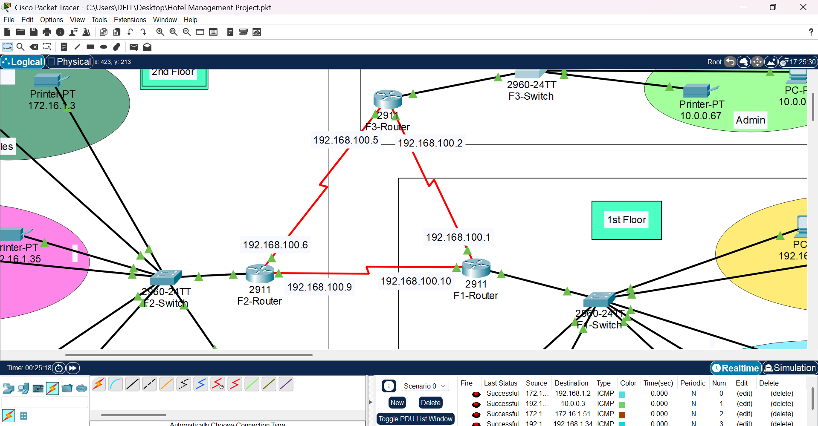

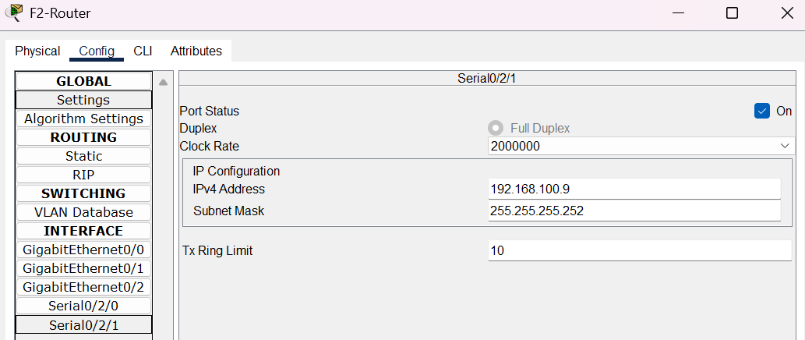
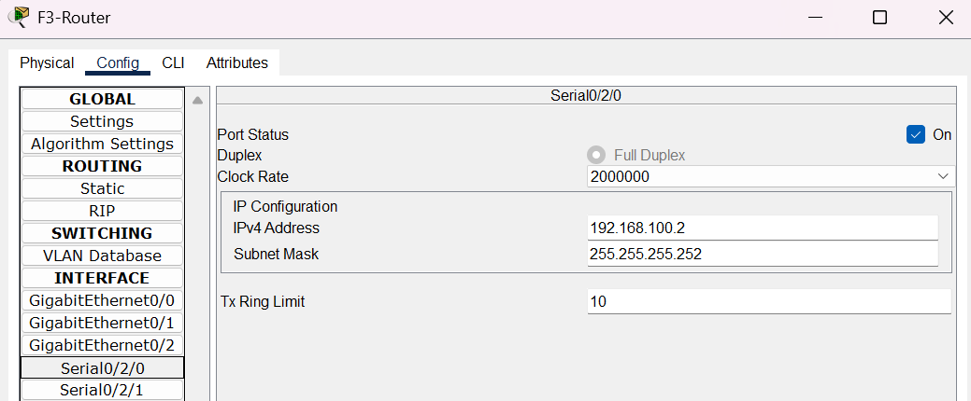
(All Serial DCE links Screen-shots not attached as that would increase file size.)
7. Router Interface Summary
7.1 F1-Router (1st Floor)
Inter-Router Interfaces
- 192.168.100.1
- 192.168.100.10
VLAN Networks
- 192.168.1.0/28 (VLAN 70 – Reception)
- 192.168.1.16/29 (VLAN 60 – Store)
- 192.168.1.32/28 (VLAN 80 – Logistics)
7.2 F2-Router (2nd Floor)
Inter-Router Interfaces
- 192.168.100.6
- 192.168.100.9
VLAN Networks
- 172.16.1.0/27 (VLAN 30 – Sales)
- 172.16.1.32/28 (VLAN 40 – HR)
- 172.16.1.48/28 (VLAN 50 – Finance)
- 172.16.1.64/29 (Department Server)
7.3 F3-Router (3rd Floor)
Inter-Router Interfaces
- 192.168.100.2
- 192.168.100.5
VLAN Networks
- 10.0.0.0/26 (VLAN 10 – IT)
- 10.0.0.64/27 (VLAN 20 – Admin)
- 10.0.0.96/28 (Core Servers)
8. OSPF Routing Configuration
OSPF is configured on all routers to advertise:
- All VLAN subnets
- All inter-router /30 networks
Benefits of OSPF:
- Automatic route learning
- Fast convergence
- Scalable enterprise routing
- Supports future hotel expansion

Screen-shots:
(The CLI commands run during the working on project were lost later in the .pkt file, and so are not included in the documentation.)

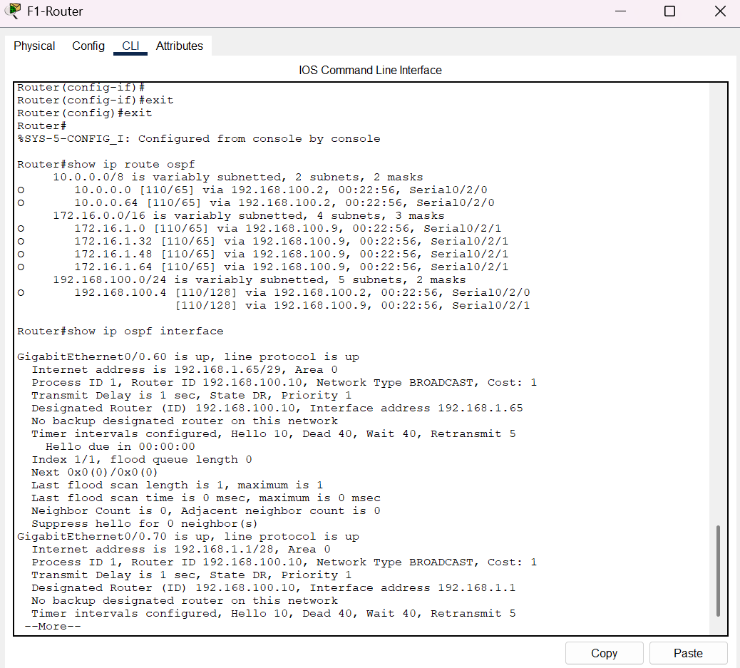
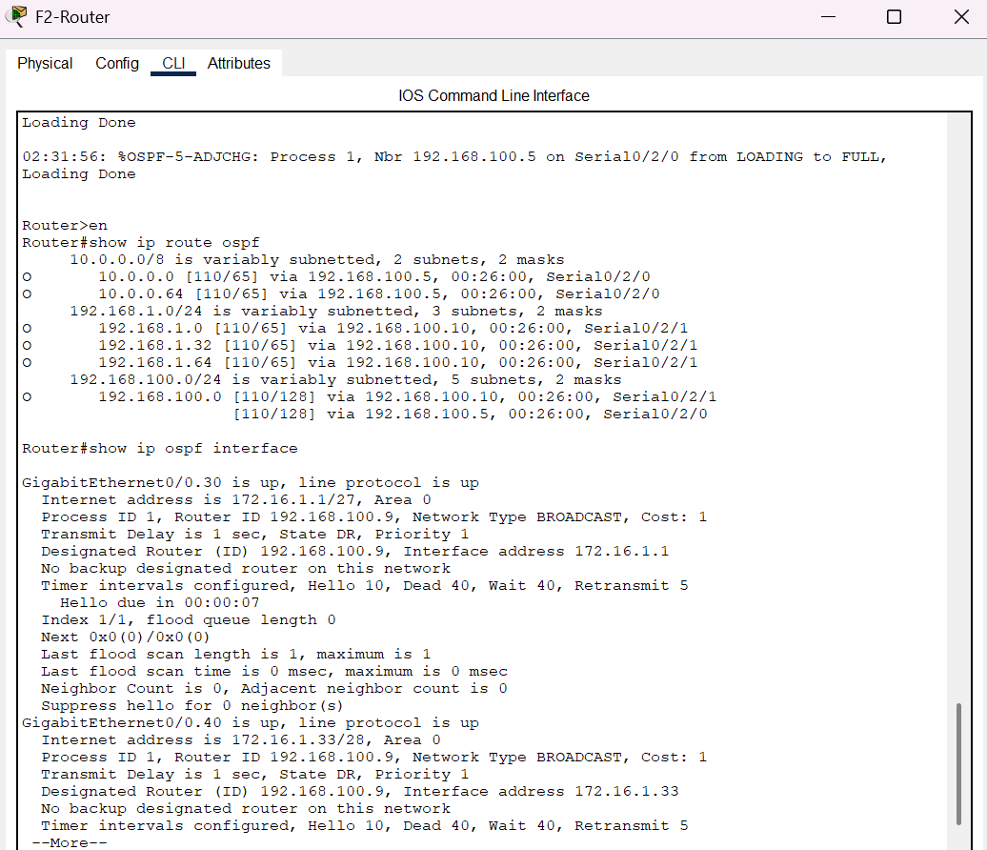
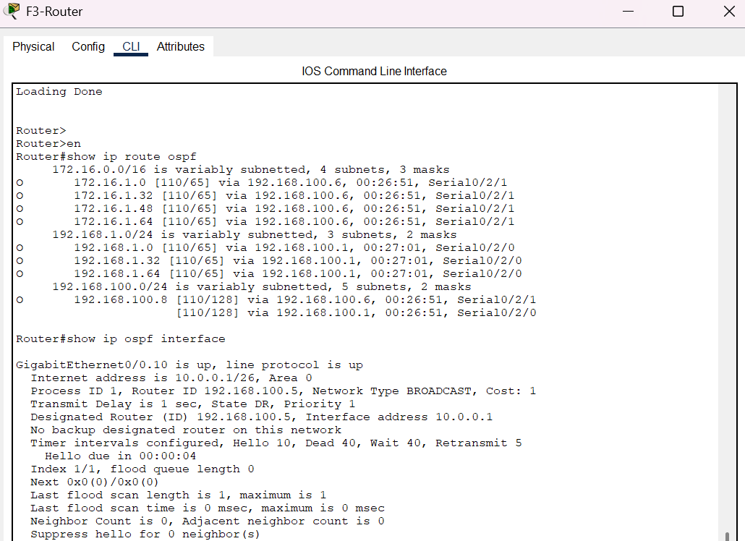
9. Printers and End Devices
Each department has its own network printer
Printers are assigned:
- Static IP addresses
- Correct VLAN membership
Justification:
- Reflects real hotel departmental operations
- Supports shared resources within departments
10. Security and Network Efficiency
- VLAN separation enhances security
- OSPF reduces routing overhead
- Controlled broadcast domains improve performance
- Logical segmentation supports future scalability
11. Testing and Verification
The following tests were performed in Packet Tracer:
- Ping tests between all VLANs on same floors
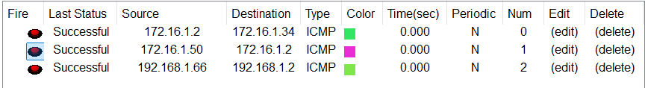
- Ping tests between all VLANs on different floors
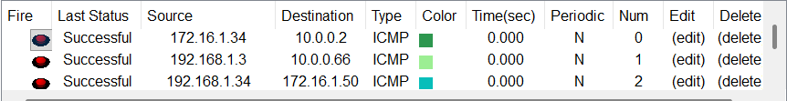
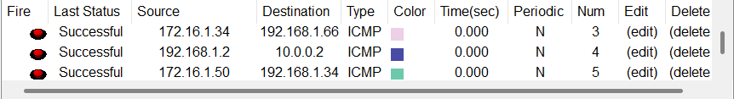
- Printer access from respective departments
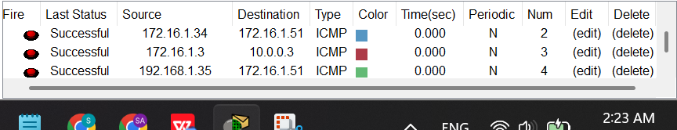
- Inter-floor communication verification
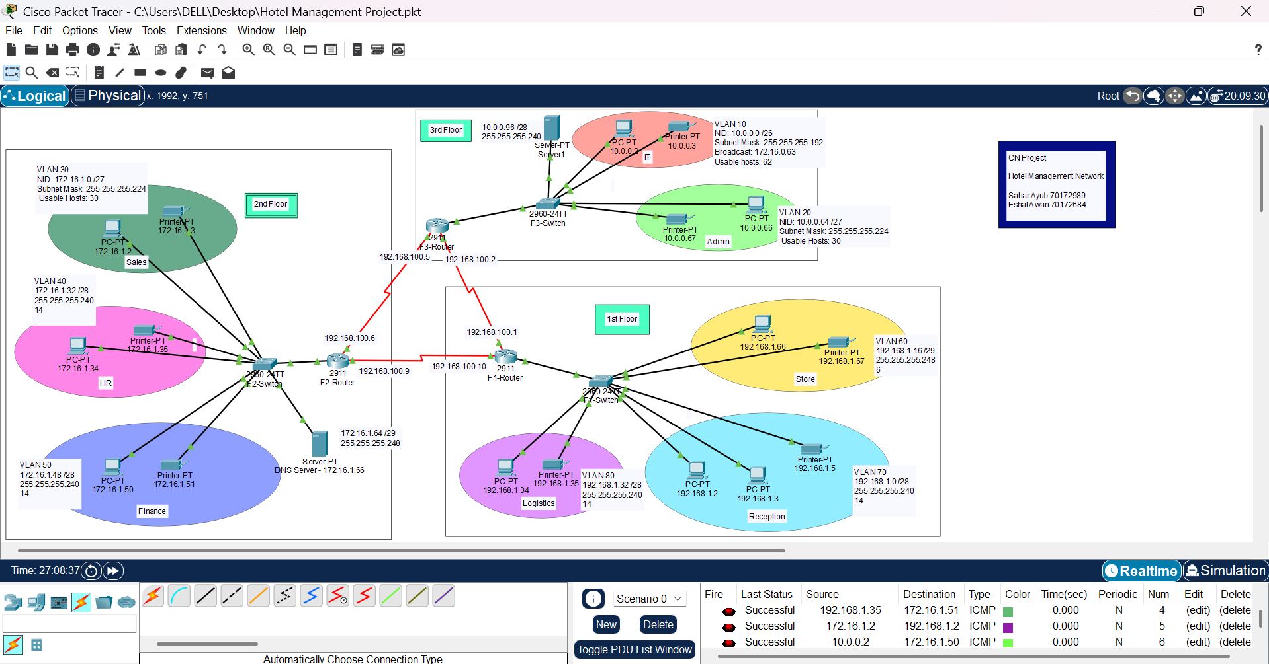
- DNS resolution testing
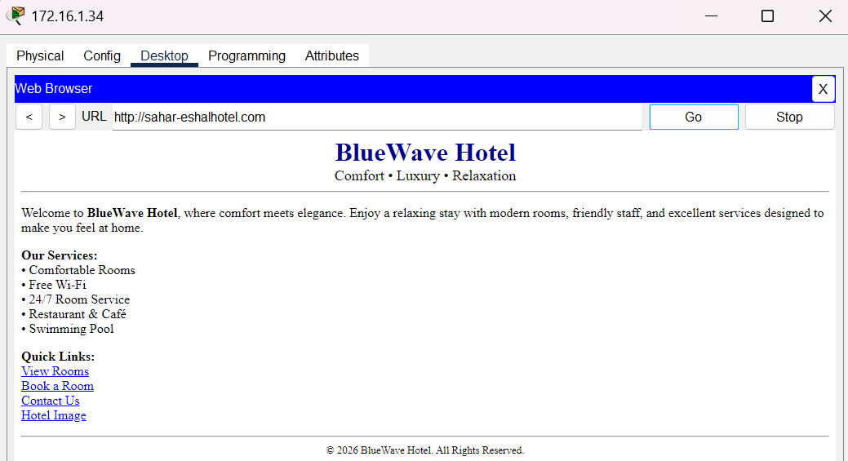
Result:
All devices successfully communicate with each other as required.
12. Conclusion
This project successfully implements a fully functional enterprise-level hotel network that meets all instructor and organizational requirements. The design demonstrates practical application of:
- VLANs and subnetting
- OSPF dynamic routing
- Server-based services (DNS)
- Wired and wireless integration
The network is realistic, scalable, secure, and operational, and if deployed in a real-world hotel environment, it would function effectively.

Thank you!

